Predicting predator search rates from metabolic rates; a bottom-up modelling approach

Flavio Affinito1, Miguel G. Matias2,3, Samraat Pawar1 and Rebecca L. Kordas1

1. Department of Life Sciences, Imperial College London, Silwood Park Buckhurst Road, SL5 7PY, Ascot UK

2. Museo Nacional de Ciencias Naturales, CSIC,, Madrid, 28006, Spain

3. InBio/CIBIO, Univ. of Évora, Largo dos Colegiais, PT-7000, Évora, Portugal

Formatted for Functional Ecology

Title: currently 7043 words (including references) / 7500 max.

Abstract: currently 309 words/ 350 max.

Figures: 1-7

Tables: 0

Equations: 8

Keywords: 9/8 max

References: currently 54 (no limit)

Friendly reviewers (ideas): Tony Dell, Mary O’Connor

Official reviewers (ideas):

**Abstract**

**1.** Species adaptation to changes in their environment is observed worldwide in all temperature-dependent traits. Metabolic rates drive species biology and dynamics. We expect that as metabolic rates adapt to new environmental conditions these will result in mismatches in performance of other biological rates, such as velocity, which will in turn affect predation dynamics via predator search rates.

**2.** Here, we measure three species’ metabolic rates from populations adapted to diverse environmental conditions and build on mathematical modelling of biological rates to scale up our findings to predict changes in species velocity and predator search rates. We look for temperature performance curve adaptation of three aquatic invertebrates and consider how the ensuing adaptation patterns are reflected on predator search rates.

**3.** Our results suggest that species adapt to warmer conditions by shifting their temperature performance curves vertically. We find that adaptation patterns are not consistent across species. Predator metabolic rates increase faster in warmer environments than prey rates driving greater mismatches in performance as conditions get hotter.

**4.** Mechanistic modelling predictions reveal that the predator species in our system is benefitting disproportionately from the effects of warming via an increase in body velocity relative to that of its prey. This performance mismatch is responsible for changes in search rate estimates where predators in warmer conditions display higher search rates regardless of prey type.

**5.** Our results provide the first attempt at providing a theoretical framework for predicting species interactions from temperature-dependence of metabolic rates. Key assumptions can be adapted to any system and will allow for a greater understanding of the effects of warming on biological systems.

**Keywords:** adaptation, temperature performance curve, respiration, search rate, velocity, metabolic rate, predator-prey, modelling, metabolic mismatch

**Introduction**

Climate change is modifying environments on a global scale, forcing species to move, adapt or go extinct (Walther *et al.*, 2002; Thomas *et al.*, 2004). Warming in particular is a major climate change-related threat to the environment (Houghton, 1996; Stocker, 2014). Temperature is one of the most important abiotic factors that influence ecological processes, from individual metabolism (Gillooly *et al.*, 2001) to ecosystem dynamics (Saxe *et al.*, 2001; Yvon-Durocher *et al.*, 2012). These rapid increases in climatic temperature are already affecting a wide range of biological traits and ecological processes that depend on temperature (Coley, Bryant and Chapin III, 1985; Loreau *et al.*, 2001), having a direct impact on species and their interactions (Hughes, 2000; Peñuelas and Filella, 2001). Indeed, exposure to novel environments pushes species to change their biological rates; adapting within the limits of their physiology. Despite the extensive body of work on how temperature affects individuals and populations (Gillooly *et al.*, 2001; Clarke, 2003; Brown *et al.*, 2004), we still don’t understand how these individual-level changes influence the interactions between species . We still require a better understating of what adaptation of individual species will look like and whether it will change the way they interact in novel environments. Adaptation of species’ populations to differing environments and thermal regimes may cause relative changes in biological rates between species with nontrivial consequences for predator-prey dynamics.

Individual metabolic rates typically display a unimodal relationship with temperature (the thermal performancecurve, TPC) (Angilletta, 2006; DeLong *et al.*, 2017; Kontopoulos *et al.*, 2018; Figure 1). In novel environments, species may experience conditions that allow (e.g., change in resources) or force (e.g., change in predation risk) a change in metabolic rate (demand for ATP), and consequently, respiration rates, which will affect individual biology from growth rates to fitness (Clarke, 2003, 2006; Brown *et al.*, 2004). Various scenarios of adaptation of TPCs to new environmental conditions are possible (Kingsolver, 2009; Figures 1A&B), which scale up to their population dynamics (Rall *et al.*, 2010; Vucic-Pestic *et al.*, 2011; Dell, Pawar and Savage, 2014; Gilbert *et al.*, 2014; Pawar, Dell and Savage, 2015). Warmer environments put species under more pressure to perform to meet oxygen demand, resulting in a vertical shift in the whole TPC (Figure 1A; Kingsolver, 2009). Alternatively, TPCs may change shape and become “steeper” as performance is maintained over the OTR but increased at hotter temperatures (Figure 1B; Angilletta, 2009). As the environment changes, the curves of interacting species may change in shape relative to each other, producing ‘mismatches’ in performance between predators and their prey (Dell, Pawar and Savage, 2014; Fig 1C&D). As metabolic rates adapt to new environments, these mismatches in performance will modify interaction strengths. These in turn could increase consumption rates, modify community dynamics and lead to changes in ecosystem assemblages and increase extinction risk (Rall *et al.*, 2010; Albouy *et al.*, 2014).

We approach the question of how species interactions could change in warmer environments by considering how adaptation of respiration rates might be used to predict the effect of environmental change on predator search rates (the time taken to search a unit area or volume of environment for target resources; ). It has been suggested that search rates are affected by temperature (Rall *et al.*, 2010, 2012; Vucic-Pestic *et al.*, 2011) but a mechanistic understanding of this effect is still largely lacking. Search rates are determined by the biological traits of the resource and its consumer (Dell, Pawar and Savage, 2014; Gilbert *et al.*, 2014) and the environmental space they interact in (Pawar, Dell and Savage, 2012). Specifically, biotic effects on search rates are determined by the relative body velocities of the predator and its prey (McGill and Mittelbach, 2006; Pawar, Dell and Savage, 2012; Dell, Pawar and Savage, 2014). Research on animal locomotion suggests that there is a simple relationship between the energetic cost of transport and metabolic rate based on locomotion type (Tucker, 1970; Videler, 1993; Gilbert *et al.*, 2014). Some of the energy produced from respiration is allocated to muscle contraction and locomotion (Alexander, 2003). Thus, changes in respiration TPCs will induce changes in velocity TPCs, in turn affecting the ability of predators to find prey, and the ability of those prey to escape. These allow us to predict how local adaptation of metabolic rates drive adaptation of species velocity and how the arising mismatches in trait performance result in altered predator search rates.

In this study, we combine empirical data and mathematical modelling to… To this end, we measured whole-organism metabolic rates of individual insects adapted to different habitats in a natural climatic gradient in Spain. We then used a mechanistic model to predict how adaptation to the environmental gradient may affect search rates. Bridging the gap between metabolism, velocity and search rates in this way allows for predictions of (seldom-measured) search rates, using (commonly-acquired) respiration rates.

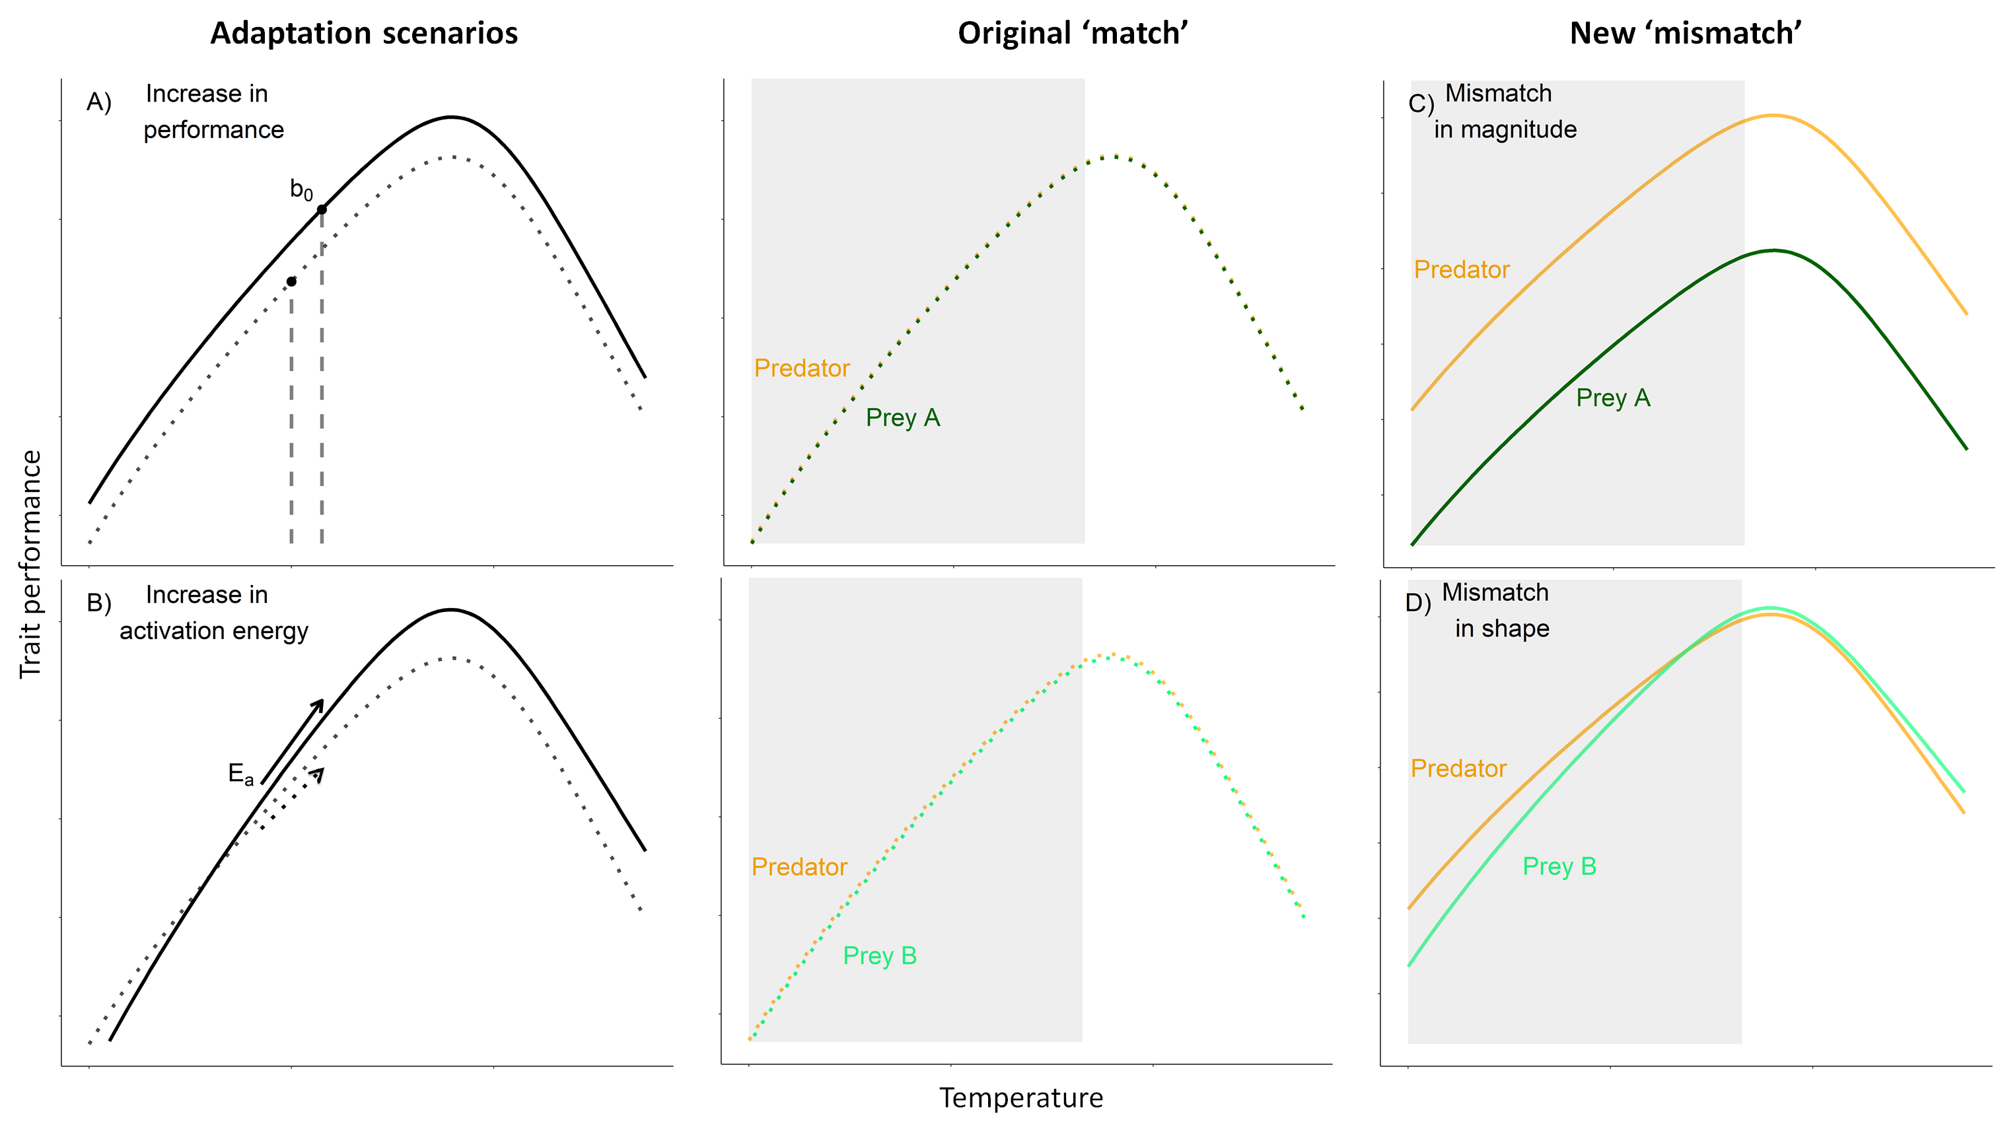

Figure 1. **Adaptation of temperature-dependent rates may lead to mismatches in performance between interacting species.** Metabolic rates can be modelled as a unimodal function of temperature determined by biochemical processes (enzyme activation (*Ea*) and deactivation (*Ed*) energies) and biological parameters (*Tpk* and *b0*) from equation 1. We estimated *b0* at the mean habitat temperature, representing the average performance at a given site. The TPC for a species from a cooler habitat (dotted lines) may change in different ways when it has adapted to a warmer habitat (solid lines): for example, (A) a vertical shift in performance would increase *b0* or (B) the steepness of the curve (*Ea*) could change. In a habitat with multiple interacting species, predator (orange) and prey (greens) may have similar TPCs in cooler habitats (center panels). However, if predator and prey adapt to higher temperatures in different ways (eg, predator adapts via an increase in scenario (A) and prey adapt via decrease in scenario (A) or via scenario (B)), then their TPCs may become ‘mismatched’ (C&D). The mismatch caused by adaptation is particularly important within the operational temperature range of species (grey area). Adapted from Angilletta, 2009; Kordas, Harley and O’Connor, 2011; Dell, Pawar and Savage, 2014.

**Methods**

We used a space-for-time substitution for adaptation by sampling three aquatic invertebrate taxa from a suite of experimental mesocosm sites around the Iberian Peninsula, with sites located in regions that experienced diverse environmental conditions. The focal insect taxa are geographically widespread across Europe and occupy different ecological niches in lentic systems: a mobile swimming predator, a mobile swimming herbivore prey and a sediment-dwelling detrivore prey. We ask whether respiration rates of all three taxa differ between sites and look for changes in their TPCs. We consider these changes in respiration TPCs by comparing velocity TPCs and looking for relative differences in performance. Finally, we predict changes in predator search rates from mismatched velocity curves to look for changes in interaction strengths.

STUDY SITES

We measured oxygen consumption rates of insects from six sites around the Iberian Peninsula, that varied in altitude and latitude (Fig S1). At each site, 32 artificial mesocosm ponds (each 320L) were seeded with an assemblage of freshwater species collected from a nearby water bodies (including lakes, ponds and small streams) during Autumn (2014) and Winter (2014-2015). The communities in the mesocosms were then left to assemble naturally over the following two years. Most invertebrate species found in the ponds are efficient dispersers upon reaching adult stage and were found throughout ponds and across sites (Matias, unpublished data). We sampled the ponds during the local spring season at each site (April to May 2017). Mesocosm temperatures were recorded with submerged loggers every hour starting when each site was constructed. The sites experienced significantly different thermal regimes (Figure 2) and mean temperatures (+/- 95%CI): Peñalara (7.35 ± 0.05°C), Jaca (11.05 ± 0.04°C), Porto (12.7 ± 0.03°C), Toledo (13.47 ± 0.03°C), Évora (14.92 ± 0.03°C) and Murcia (16.23 ± 0.03°C).

STUDY ORGANISMS

Experiments were carried out on three aquatic insect taxa from the Iberian Peninsula. Individuals were collected with 500μm mesh nets from freshwater mesocosms and were identified to genus level or species level following experiments and preservation. We targeted species based on and trophic level (predator vs. prey) and abundance at each site (minimum 100 individuals). Not all species were found in sufficient numbers needed for conducting the experimental trial at all six sites (Supplementary material Table S1).

Differences in locomotion result in changes in the relative velocities of prey and predator (Pawar, Dell and Savage, 2012). We carried out overnight feeding trials to determine the relationship between all taxa and identified *S. striolatum* as a predator(Supplementary material). The foraging strategy of the predator on each prey was determined based on the morphology and locomotive behaviour of each prey taxa. In their aquatic stage, *S. striolatum* (predator) and *C. dipterum* (prey) are free-swimming pelagic species (Merritt and Cummins, 1996; Bauernfeind and Soldan, 2012). In contrast, *Chironomus* spp. (prey) are benthic and found mostly living in the sediment (Cranston, Pinder and Armitage, 1995). When prey velocity was likely to be negligible relative to that of the predator, we classified the interaction as a “sessile prey” strategy. In contrast, when prey velocity was non-negligible and likely to affect the predator’s ability to capture prey, we defined the foraging strategy as “active capture”. These distinct foraging strategies are expected to produce different interaction strengths based on the environmental space they occur in. Indeed, search rates of predators hunting in 3D environments are known to vary from those hunting in a 2D space (Pawar, Dell and Savage, 2012). Thus we considered both, foraging strategy and the dimensionality of the environment, to understand how interaction rates changed with environmental adaptation.

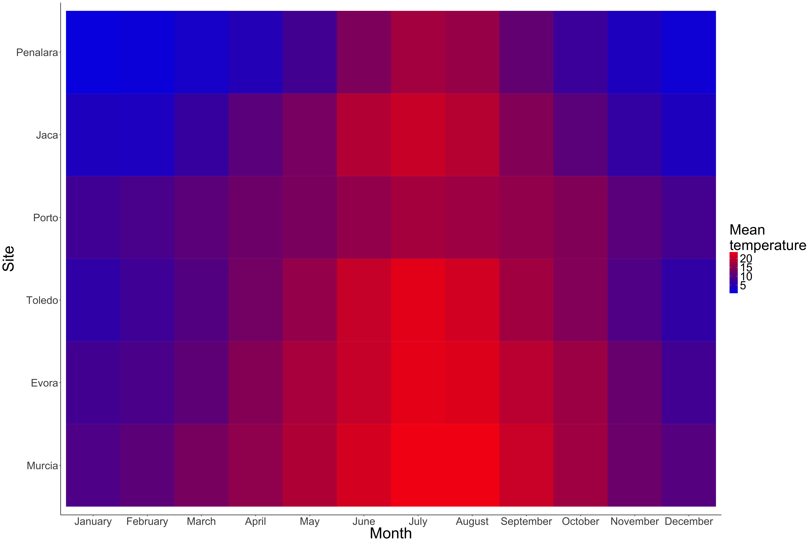

Figure 2. Mean monthly temperatures recorded at each site. We used a space-for-time substitution to look for adaptation of respiration rates as all sites experienced differences in temperature due to their geographical position.

METABOLIC RATE EXPERIMENTS

Metabolic rates increase as demand for ATP in the body increases (Clarke, 1993), requiring that individuals consume more oxygen per unit time (Clarke, 2003, 2006). We measured respiration rates as a proxy for metabolic rate, following a protocol similar to that of Brodersen et al 2008. For each population, we measured individual oxygen consumption rates at acute temperatures spanning 10-45°C at 5°C intervals, as it is necessary to capture both the rise and fall components of TPCs (should we refer back to Figure 1 here?) to avoid introducing bias in the estimation of their parameters (Pawar *et al.*, 2016).

Prior to measurements, individual insects were stored for 24 hours in containers filled with mesocosm water that had been filtered using 20μmmesh nets and held at ambient temperature and daylight?. This allowed for gut clearing of all taxa, since digestion status can affect respiration rates. Individuals were acclimated to acute experimental temperatures for 15 minutes prior to respiration measurements to avoid a shock response; insects were placed in a plastic container filled with 100ml of filtered pond water at ambient temperature, which was then placed in a water bath set to the acute temperature. This allowed the water inside the container to reach the acute temperature within ~15 minutes.

For each respiration trial, eight glass vials were filled with filtered air-saturated water from the local mesocosms, which was kept at the experimental temperature. A magnetic stir bar maintained mixing of the water column in each glass vial, and a small mesh screen was placed in between the stir bar and the organism to avoid stressing the organism. One individual was placed into each of seven glass vials, while the eighth vial contained filtered water only and thus served as a control to account for sensor drift and the oxygen changes due to microorganisms in the mesocosm water. All vials were then sealed and fully immersed in a water bath set to the experimental temperature. Individuals were only used once.

Oxygen concentration was measured during three periods of ~30 seconds each (logging every second) using an oxygen microelectrode (MicroResp, Unisense, Denmark) fitted through a capillary in the lid of each vial. Oxygen concentrations were not allowed to drop below 70% of the starting value, to minimize stress to the insects. The oxygen consumption rate of each individual was calculated as the slope through all of the data points, and was corrected for differences in vial volume and the oxygen concentration in the control vial from each trial. The body size of each individual was measured using a dissecting microscope and converted to dry mass using length-weight relationships measured for taxa from our sites (Supplementary methods).

**Modelling and model fitting**

Temperature dependence of respiration was modelled using a modified Sharpe-Schoolfield model (Schoolfield, Sharpe and Magnuson, 1981):

|  |  |  |
| --- | --- | --- |
|  | $$B= \frac{b_{0}m^{β}e^{\frac{-E_{a}}{k}\left(\frac{1}{T}-\frac{1}{T_{ref}}\right)}}{1+ e^{\frac{E_{d}}{k}\left(\frac{1}{T_{pk}}-\frac{1}{T}\right)}}$$ | (1) |

Here *B* is oxygen consumption rate, *b0* is the normalisation constant at a reference temperature (*T*ref), *m* is mass, *β* is its scaling exponent, *Ea* is the activation energy, *Ed* is its deactivation energy, *k* is Boltzmann’s constant, *T* is acute temperature and *Tpk* is the temperature at which the *B* is maximised. We expected baseline performance (*b0*) to be adapted to the temperatures experienced at a species’ local habitat. Thus, the mean temperature at each site was used as reference temperature (*Tref*) to estimate a biologically relevant value for *b0*. The model was fitted using non-linear least squares (NLLS) to each species’ site-specific TPC. We used the minpack.lm NLLS package (Elzhov *et al.*, 2016) in R (R Core Team, 2015). The starting parameters for the NLLS procedure were sampled xxxx times from a normal distribution centred on values estimated from a linearised Arrhenius function to determine the parameter values that yielded the best fit to the data within the OTR. The best fit was determined from each such ensemble of fits based on highest R2, and lowest AIC and BIC when R2 values were equal. We fitted the model with both, a fixed *β* = 0.75for all taxa (Brown *et al.*, 2004), and allowing for species-specific variation in the scaling exponent using model selection (Supplementary material; Table S2).

The Sharpe-Schoolfield model (equation 1) was fitted to the respiration data for each population. The best-fit model out of 10,000 runs in each case was kept to estimate the values of *Ea, Ed, B0, β* and *Tpk* (Table S3). Estimated parameter values from each TPC were then compared between populations. Parameter values were considered statistically different from each other when associated 95% confidence intervals did not overlap.

BODY VELOCITY CALCULATIONS

The energetics of animal movement, and specifically swimming, have been extensively studied for various species (Videler and Nolet, 1990; Videler, 1993; Alexander, 2003). Assuming that velocity scales linearly with metabolic rate (Tucker, 1970; Alexander, 2003), there is a relationship between cost of transport (*C*), the amount of energy (in J) needed to transport 1N over 1min submerged swimmers, and metabolic rate (*B*). Rearranging Videler’s equation for velocity yields:

|  |  |  |
| --- | --- | --- |
|  | $$v= \frac{B_{j}}{Cmg}$$ | (2) |

Where *Bj* is oxygen consumption rate expressed in J.s-1, *m* is mass in kg, *g* is gravitational acceleration in m.s-2, *v* is velocity in m.s-1, *C* is expressed in J.Nm-1and was calculated from: *C* = 1.1*m*-0.038 (Videler, 1993).

We assumed that the energy allocated to muscle contraction and movement comes from the combustion of nutrients via oxygen consumption (Merrill and Watt, 1973; Elliott and Davison, 1975; Food and Agriculture Organization, 2015). Metabolism TPCs for each predator-prey pair, at each site, were thus converted into a measure of velocity using equation 2*:*

|  |  |  |
| --- | --- | --- |
|  | $$v=\frac{Bγ}{1.1m^{0.962}g}$$ | (3) |

Where *γ* is the conversion coefficient of oxygen combustion into energetic output. The temperature dependence of *v* is captured in the *B* term (from equation 1). There are known limitations to this model: measured metabolic rates are converted into a measure of velocity without taking into account increases in metabolism during activity and the efficiency of energy conversion by muscles is ignored. Nevertheless, we expect that this model will provide us with a mechanistic prediction of species velocity which can in turn be used to predict predator search rates in various conditions and for any given species where mass and metabolic rates are known.

SEARCH RATE CALCULATIONS

To predict the strength of predator-prey interactions, we focused on search rate: the rate at which a consumer moves through an area or volume while searching for prey. In field conditions, search rate is a key limiting rate underlying consumer-resource dynamics because it determines the rate of encounter when resources are relatively rare (McGill and Mittelbach, 2006; Pawar, Dell and Savage, 2012). Search rates are determined both by environmental dimension and biological traits as:

|  |  |  |
| --- | --- | --- |
|  | $a= v_{r}D$, | (4) |

where *v*ris the relative velocity of a predator and its prey and *D* is the dimensionality component of search rates. Velocity is a biological rate that can be modelled as a function of temperature (Dell, Pawar and Savage, 2014). The temperature dependence of relative velocity for two species moving randomly can be included into equation 4 from equation 3 for both the consumer and resource species (Supplementary material) as:

|  |  |  |
| --- | --- | --- |
|  | $$a= \left(b_{0,c}{m_{c}}^{β_{c}}e^{\frac{{-E}_{c}}{k}\left(\frac{1}{T}-\frac{1}{T_{ref}}\right)}+\sqrt{1+{\left(\frac{b_{0,r}}{b_{0,c}}\right)}^{2}{\left(\frac{{m_{r}}^{β_{r}}}{{m_{c}}^{β_{c}}}\right)}^{2}e^{\frac{2}{k}\left(\frac{1}{T}-\frac{1}{T_{ref}}\right)\left(E_{c}-E_{r}\right)}}\right)D$$ | (5) |

Where *b0* is the normalisation constant for velocity at a reference temperature (*Tref*), set here at the mean temperature for each site, *m* is mass, *β* is the mass scaling exponent, *E* is activation energy, *T* is temperature (in K), *k* is Boltzmann’s constant and *c* or *r* subscripts correspond to consumer (predator) and resource (prey) parameters respectively. This model predicts the search rate of a predator foraging on an active moving prey in different environments, for benthic species, such as *Chironomus* spp., it can be adapted to a scenario of sessile prey by setting the prey’s velocity to 0:

|  |  |  |
| --- | --- | --- |
|  | $$a= b_{0,c}{m_{c}}^{β_{c}}e^{\frac{{-E}_{c}}{k}\left(\frac{1}{T}-\frac{1}{T_{ref}}\right)}D$$ | (6) |

We can expand the dimensionality term *D* for interactions taking place in 2D or 3D (Pawar, Dell and Savage, 2012). To account for the environment (benthic or pelagic) each prey species interacts with the predator in, we modelled search rates separately in 2D or 3D interactions as follows:

|  |  |  |
| --- | --- | --- |
|  | $$2D :a=v_{r}2d_{0}{(m_{c}m_{r})}^{p_{d}}$$ | (7) |

|  |  |  |
| --- | --- | --- |
|  |  | (8) |

Where *d0* is the minimum reaction distance, *mc* and *mr* are average consumer and resource body mass respectively, and *pd* is the scaling exponent of mass with dimensionality. The values of *pd* in 2D and 3D were empirically derived from meta-analysis and are equal to 0.68 and 1.05 respectively (Pawar, Dell and Savage, 2012).

The model output was compared between predator-prey pairs adapted to warm and mild environments to observe the effect of local adaptation on search rates. We used a linearised Arrhenius function to estimate the biological parameters determining search rates (*Ea* and *b0*) at each site and for each strategy and plotted the changes in parameter values to look for changes in search rates due to adaptation to warmer environments.

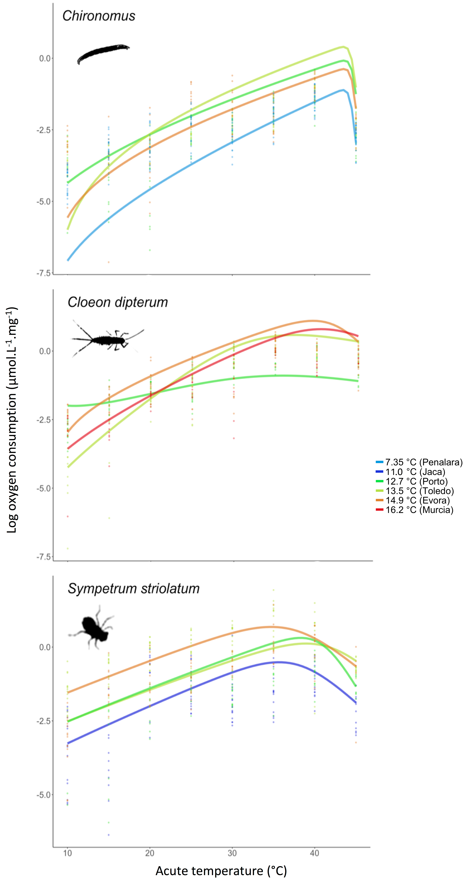

Figure 3. **Metabolic thermal performance varies across sites.** Mass corrected respiration temperature performance curves for (a) *Chironomus* *spp*, (b) *C. dipterum* and (c) *S. striolatum* modelled using the Sharpe-Schoolfield model (equation 1). Number of individual measurements for each curve varied from 52 to 164 (Supplementary material Table S3). Note that…

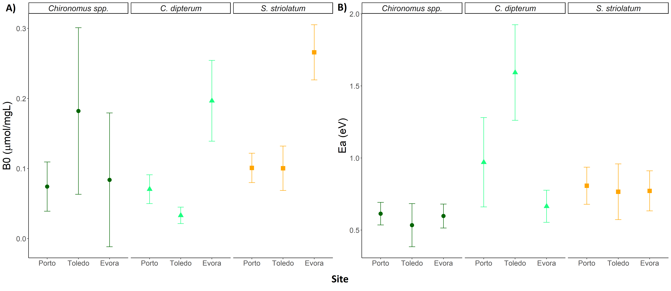

Figure 4. **Parameter estimates for each species, from each site where both prey and predator were found.** Baseline performance (A) and activation energy (B) were estimated from the Sharpe-Schoolfield model fitted to respiration rates. Error bars are 95% confidence intervals. Note that…

**Results**

We observed a vertical shift in the TPCs of respiration in both *Chironomus* spp. and *S. striolatum* (Figure 1A),with curves from the hottest site increasing in height for *S. striolatum* but decreasing for *Chironomus* spp. (Figure 3). *C. dipterum’s* TPCs changed both in elevation and shape in warmer environments (Figures 1A, 1B & 3). We found a directional vertical displacement in TPC for both *S. striolatum* and *C. dipterum*,with the warmest site displaying a significantly greater *b0* than both cooler locations (Figure 3A). We found much greater variation between sites in *b0* for *Chironomus* spp., and no directional pattern in elevation change (Figure 3A). Activation energy did not change for *Chironomus* spp. or *S. striolatum* between sites (Figure 3B). We found a significant increase in *Ea* for *C. dipterum* at intermediate site, Toledo, and higher activation energies than for the other taxa (Figure 1B).

*S. striolatum* displayed relatively higher predicted velocity than either prey taxa over all the operational temperature range (Figure 5). The relative difference in curve elevation was greater for the *S. striolatum-Chironomus* spp. pair than for *S. striolatum-C. dipterum* at both sites. We found a mismatch in magnitude for the *S. striolatum-Chironomus* spp. pair (Figure 1C) and a mismatch in shape for the *S. striolatum-C. dipterum* pair (Figure 1D). The mismatch in magnitude for the *S. striolatum-Chironomus* spp. was greater in the warmer site as the predator TPC shifted upwards and the prey TPC shifted downwards (Figure 5). However, the mismatch was constant over the OTR with the relative difference in elevation neither increasing nor decreasing within a site as curve steepness did not vary. Velocity TPC steepness changed for *C. dipterum*,resulting in a shape mismatch in the pair with the curves of the prey and predator converging over the OTR in the warmer site but diverging in cooler conditions (Figure 5). The relative difference in elevation is thus greater at cooler temperatures in the warm site whilst it is greater at warmer temperatures in the cool site.

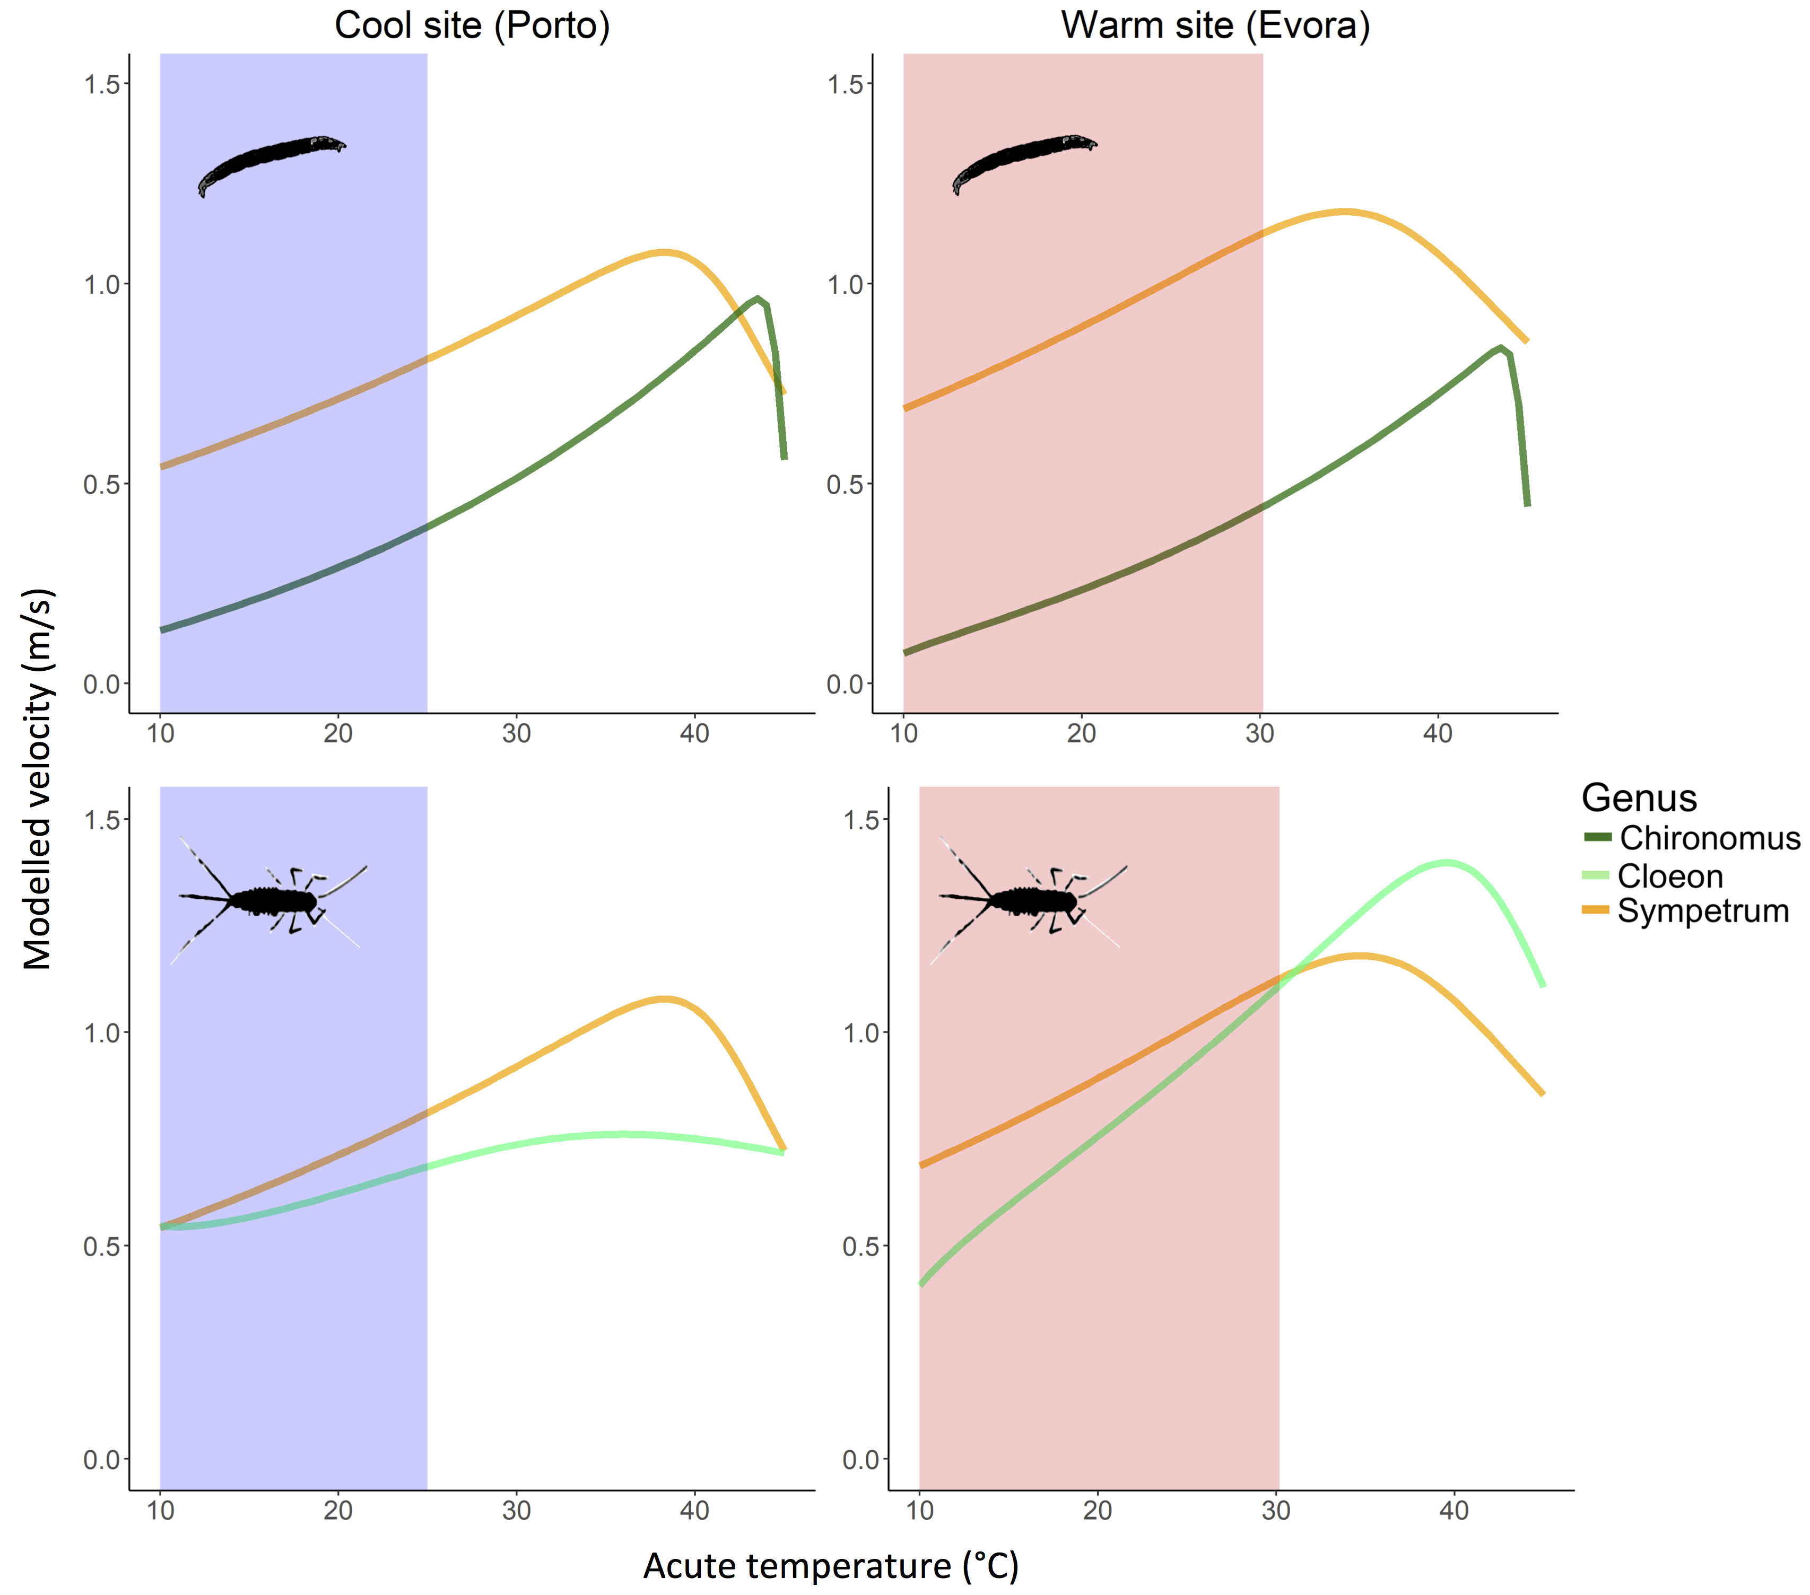

Figure 5. **Mismatches in velocity with adaptation to local environment.** Predator-prey velocity curves for cool Porto versus warm Evora for each predator-prey pair estimated from respiration rates (equation 3). Coloured areas correspond to the range of recorded temperatures (operational temperature range) of the sites. Note that…

TEMPERATURE EFFECTS ON SEARCH RATES

Similar patterns in the temperature dependence of modelled search rates emerge for both foraging strategies in both dimensionalities across sites and species. For both species pairs and all foraging strategies at both sites, the predicted search rate increased with acute temperature (Figure 6). The active 2D strategy displayed the highest search rates, while the 3D sessile prey model estimates were consistently lower over the OTR, in all cases. Search rates were greater for the *S. striolatum-Chironomus* sp. pair than for *S. striolatum-C. dipterum* pair at each site. Both the most biologically relevant models (“sessile 2D” for *S. striolatum-Chironomus* spp. and “active 3D” for *S. striolatum-C. dipterum*) revealed a sharp increase in search rates in warmer conditions (Figure 6, bold lines).

Differences in search rate elevation and steepness were calculated by subtracting cold site values from warm site values and show the effect of warmer conditions (Figure 7). Both elevation and steepness were greater in warmer environments, for all strategies in both species pairs. Search rate elevation and steepness values for *C. dipterum* predationrevealed a greater increase in warmer sites than those for *Chironomus* spp. predation.

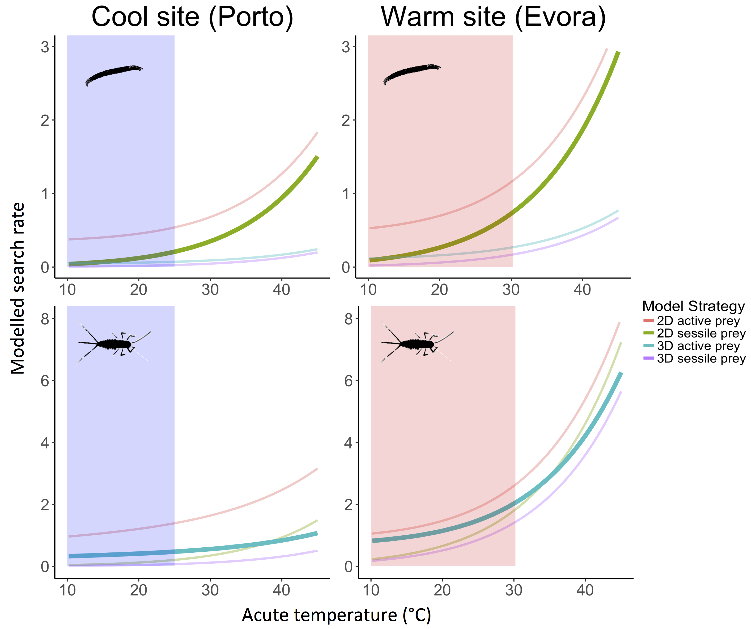

Figure 6. **Site-specific exponential increase in search rates with temperature.** Search rate model estimates for *Chironomus* spp (top panels). and *C. dipterum* (bottom panels) in cool Porto or warm Evora increase for all foraging strategies within the OTR (coloured area). Thicker curves correspond to the most biologically relevant model for the interacting pair, based on observations of insect movement in nature. Note that…

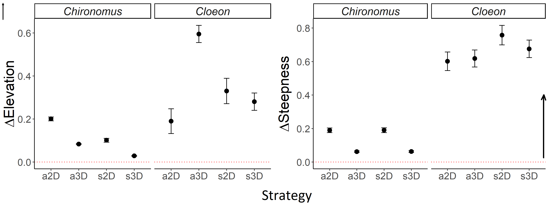

Figure 7. **Differences in search rate elevation and steepness between warm and cold acclimated species.** Search rates for *Chironomus* spp.and *C. dipterum* display an increase in both elevation and steepness for all strategies adapted to a warm site. Values were calculated by subtracting parameter estimate values for cool Porto to those from warm Evora. Error bars represent 95% confidence intervals. Arrow indicates a positive change.

**Discussion**

We have identified patterns of metabolic adaptation to new environmental conditions, and modelled how these scale up to differences in the temperature dependence of body velocity and species interaction rates. We find support for both hypothetical adaptation scenarios (vertical displacement and change in steepness) of biological rate temperature curves with increasing environmental temperatures. By estimating velocity using respiration rates, we show that the predator-prey pairs in this system are currently mismatched in their relative performance, that this mismatch changes with environmental conditions and that it is specific to each pair. Finally, we show that as biological rates increase with temperatures, expected search rates increase in both elevation and steepness, strengthening predator-prey dynamics in warmer conditions.

*S. striolatum* and *Chironomus* spp. displayed a vertical shift in respiration TPCs alone with no variation in activation energies. *C. dipterum* curves showed both a change in elevation and in steepness with significant changes in *Ea*. Changes in the elevation parameter, *b0*,were consistent between *S. striolatum* and *C. dipterum* with hotter sites having significantly higher values. These results support for both adaptation scenarios, with *S. striolatum* and *Chironomus* spp. fitting scenario 1A alone and *C. dipterum* matching a combination of Fig. 1A&B. Higher temperatures experienced in warmer environments pose increased stress on species physiology via increased demand for ATP production (Clarke, 2003). Mechanisms such as a vertical shift in the entire curve provide an increase in oxygen availability for a species at all temperatures throughout the OTR (Angilletta, 2009; Kingsolver, 2009). However, such adaptation can only be pushed within the limits of an organism’s physiological plasticity and some environmental temperatures may be too much for a species to cope with, as is the case for warm site *Chironomus* spp. here but not *S. striolatum*. Increased steepness of the curve provides increased O2 at higher temperatures, that are more likely to be experienced in warmer conditions, but comes at a cost at lower temperatures where performance is lowered. These mechanisms of change in the shape of respiration TPCs in the face of warming conditions suggest a species-specific response to temperature with a common pattern of vertical shifting of varying magnitude and direction.

Converting metabolic rate measurements into velocity, a key driver of species interactions (Dell, Pawar and Savage, 2014), enabled us to assess how the environment affected the mismatch in performance between predator and prey. The *S. striolatum-Chironomus* spp. pair showed a mismatch in magnitude strengthened by the effect of a warming environment. The velocity TPC of the predator increased in height whilst that of its prey decreased, resulting in *S. striolatum* moving relatively faster than *Chironomus* spp. over the OTR in warmer conditions. The *S. striolatum-C. dipterum* pair showed a mismatch in shape which changed orientation with warming. As temperature increased in warm environments, the predator-prey TPCs converge whilst they diverge in cooler conditions. These results will lead to asymmetrical changes in performance and thus interaction strengths (Angilletta, 2009; Kordas, Harley and O’Connor, 2011; Gibert and DeLong, 2014; Pawar, Dell and Savage, 2015). The greater increase in *S. striolatum* respiration *b0* than either of its prey will result in relatively more O2 availability, ATP production, performance and interaction strengths over the OTR. *C. dipterum* from warmer sites move relatively faster when temperatures increase, providing a thermal niche where predators will be less able to catch them, lowering interaction strengths. However, at temperatures close to the mean of each site, *S. striolatum* from warmer sites are able to move relatively faster than either prey compared to their counterparts from cooler sites. At the warmer sites in the Iberian Peninsula, *S. striolatum* may be more efficient at feeding on both these prey speciesas they are able to move faster, increasing potential attack and capture rates.

Predator-prey interactions are key to community-level dynamics in aquatic environments (Pawar, Dell and Savage, 2015). Here we show how mechanistic models for search rates can built using metabolic rate data. We find support for an increase in search rates with temperature (Brown *et al.*, 2004; Vucic-Pestic *et al.*, 2011; Rall *et al.*, 2012). This relationship is maintained across foraging strategies but the magnitude of the increase varies with interaction dimensionality, emphasizing its importance in species interactions (Pawar, Dell and Savage, 2012). The strength of the relationship between search rates and temperature depends both on dimensionality and on the species interacting in that space. Here, we find that dimensionality plays a larger role in search rates for *Chironomus* spp. whilst foraging strategy drives increased search rates in *C. dipterum*. Indeed, 2D environments display the sharpest increase for the former whilst it is active strategies for the latter. Thus, although biochemical processes result in similar patterns of search rate increase in warmer conditions, it is important to consider specific prey items and the environment they interact in when modelling search rates. Nonetheless, the overall increase in search rate elevation in species from warmer sites suggests that as the difference in performance of velocity increases close to a site’s mean temperature, so do search rates. These results support the idea that the predator in this study benefits disproportionately from the warming of its environment as interaction strengths increase.

The set of assumptions of this model may limit its application to all types of predator-prey pairs. First, random movement has been shown to approximate animal dispersion in most cases but may not suffice in all (Pawar, Dell and Savage, 2015). Second, the effect of dimensionality is largely dependent on the environment and the predator’s detection mechanism, as *d0* (minimum detection distance) will depend both on the environmental medium (eg, air vs. water) and trait used (Pawar, Dell and Savage, 2012). Third, the model uses an established relationship for general forms of movement in water and cost of transport (Tucker, 1970; Videler and Nolet, 1990; Videler, 1993). Alternatives can be used based on specific locomotion techniques and the physics involved therein but this was not available for our taxa (Alexander, 2003). We suggest that this is a relatively minor drawback because it is much easier to find information on locomotion in higher taxa, and work is on-going on the physics of animal movement with regard to metabolism (Hein, Hou and Gillooly, 2012; Gibert *et al.*, 2016). However, these shortcomings all point towards the fact that more empirical work on life history, habitat choice and animal movement is needed for a better integration of computational methods into biological studies. Finally, for ease of study and because no such information was available on the energetic budgets of our species, we assumed that the energy produced by metabolism was used for the purpose of locomotion. This assumption is likely to be broken as the energy produced by metabolism needs to be allocated to several other biological needs, such as growth and maintenance. Furthermore, of the energy allocated to locomotion, a large amount will be lost due to muscular inefficiency in most animals (Alexander, 2003). Indeed, up to 60% of the energy allocated for muscle contraction may be lost due to this inefficiency (Tucker, 1975; Alexander, 2005). Although these assumptions are most likely affecting our results, we suggest that this model could be easily adapted for taxa where more information is available and may lead to predictions that can be validated empirically. This in turn would be greatly valuable to studies on the effects of global warming on the dynamics of predation as search rates are difficult to estimate experimentally (Rall *et al.*, 2010; Vucic-Pestic *et al.*, 2011).

The link between metabolic rates, velocity, their adaptation patterns and its effect on species interactions can be understood via mechanistic modelling. Species-specific metabolic adaptation to warmer environments (Figure 3), via changes in *b0* and *Ea* (Figure 4), produces mismatches in biological traits (Figure 5) that affect search rates (Figure 6). The current increase in understanding of trait temperature-dependence and the mechanics of movement enabled the design of a biologically representative model based on empirical data gathered in the field. Our study reveals patterns of environmental adaptation in a set of Iberian aquatic invertebrates, and shows how theoretical models enable qualitative predictions of complex biological traits and species interactions. Future work should focus on integrative approaches linking theoretical predictions to measured empirical data to understand the multi-level processes affecting thermal ecology. There is still much to understand about the effect temperature plays on metabolism and all the processes it controls.

**Acknowledgements**

We acknowledge the funding support of the Royal Society (RG150320) to RLK and SP, and Imperial College London to FA and RLK. Special thanks go to Dr Katarzyna Sroczynska and Miss Cátia Lucio Pereira for their support in collecting the data used in this study.

**Authors contribution statement**

F. Affinito, M. Matias, S. Pawar and R. Kordas conceived the ideas and designed methodology; F. Affinito, M. Matias and R. Kordas collected the data; F. Affinito analysed the data and developed the mathematical model; F. Affinito wrote the manuscript. M. Matias, S. Pawar and R. Kordas edited the manuscript. All authors contributed critically to the manuscript drafts and gave final approval for publication.

**References**

Albouy, C. *et al.* (2014) ‘From projected species distribution to food-web structure under climate change’, *Global change biology*. Wiley Online Library, 20(3), pp. 730–741.

Alexander, R. M. (2003) *Principles of animal locomotion*. Princeton University Press.

Alexander, R. M. (2005) ‘Models and the scaling of energy costs for locomotion’, *Journal of Experimental Biology*, 208(9), pp. 1645–1652. doi: 10.1242/jeb.01484.

Angilletta, M. J. (2006) ‘Estimating and comparing thermal performance curves’, *Journal of Thermal Biology*, 31(7), pp. 541–545. doi: 10.1016/j.jtherbio.2006.06.002.

Angilletta, M. J. (2009) *Thermal adaptation: a theoretical and empirical synthesis*. Oxford University Press.

Bauernfeind, E. and Soldan, T. (2012) *The Mayflies of Europe (Ephemeroptera)*. Brill.

Brown, J. H. *et al.* (2004) ‘Toward a metabolic theory of ecology’, *Ecology*. Wiley Online Library, 85(7), pp. 1771–1789.

Clarke, A. (1993) ‘Seasonal acclimation and latitudinal compensation in metabolism: do they exist?’, *Functional Ecology*, 7(2), pp. 139–149. doi: 10.2307/2389880.

Clarke, A. (2003) ‘Costs and consequences of evolutionary temperature adaptation’, *Trends in Ecology and Evolution*, pp. 573–581. doi: 10.1016/j.tree.2003.08.007.

Clarke, A. (2006) ‘Temperature and the metabolic theory of ecology’, *Functional Ecology*, pp. 405–412. doi: 10.1111/j.1365-2435.2006.01109.x.

Coley, P. D., Bryant, J. P. and Chapin III, F. S. (1985) ‘Resource availability and plant antiherbivore defense’, *Science*. American Association for the Advancement of Science, 230, pp. 895–900.

Cranston, P. S., Pinder, L. C. V and Armitage, P. D. (1995) *The Chironomidae : biology and ecology of non-biting midges / edited by P.D. Armitage, P.S. Cranston, L.C.V. Pinder*. Chapman & Hall London.

Dell, A. I., Pawar, S. and Savage, V. M. (2011) ‘Systematic variation in the temperature dependence of physiological and ecological traits’, *Proceedings of the National Academy of Sciences*, 108(26), pp. 10591–10596. doi: 10.1073/pnas.1015178108.

Dell, A. I., Pawar, S. and Savage, V. M. (2014) ‘Temperature dependence of trophic interactions are driven by asymmetry of species responses and foraging strategy’, *Journal of Animal Ecology*, 83(1), pp. 70–84. doi: 10.1111/1365-2656.12081.

DeLong, J. P. *et al.* (2017) ‘The combined effects of reactant kinetics and enzyme stability explain the temperature dependence of metabolic rates’, *Ecology and evolution*. Wiley Online Library.

Elliott, J. M. and Davison, W. (1975) ‘Energy equivalents of oxygen consumption in animal energetics’, *Oecologia*, 19(3), pp. 195–201. doi: 10.1007/BF00345305.

Elzhov, T. V *et al.* (2016) ‘minpack.lm: R Interface to the Levenberg-Marquardt Nonlinear Least-Squares Algorithm Found in MINPACK, Plus Support for Bounds’. Available at: https://cran.r-project.org/package=minpack.lm.

Food and Agriculture Organization (2015) *FAOSTAT*, *United Nations*.

Gibert, J. P. *et al.* (2016) ‘Crossing regimes of temperature dependence in animal movement’, *Global change biology*. Wiley Online Library, 22(5), pp. 1722–1736.

Gibert, J. P. and DeLong, J. P. (2014) ‘Temperature alters food web body-size structure’, *Biology letters*. The Royal Society, 10(8), p. 20140473.

Gilbert, B. *et al.* (2014) ‘A bioenergetic framework for the temperature dependence of trophic interactions’, *Ecology Letters*, 17(8), pp. 902–914. doi: 10.1111/ele.12307.

Gillooly, J. F. *et al.* (2001) ‘Effects of size and temperature on metabolic rate’, *Science*, 293(September), pp. 2248–2251. doi: 10.1126/science.1061967.

Hein, A. M., Hou, C. and Gillooly, J. F. (2012) ‘Energetic and biomechanical constraints on animal migration distance’, *Ecology Letters*, 15(2), pp. 104–110. doi: 10.1111/j.1461-0248.2011.01714.x.

Houghton, J. T. (1996) *Climate change 1995: The science of climate change: contribution of working group I to the second assessment report of the Intergovernmental Panel on Climate Change*. Cambridge University Press.

Huey, R. B. and Kingsolver, J. G. (2011) ‘Variation in universal temperature dependence of biological rates’, *Proceedings of the National Academy of Sciences*, 108(26), pp. 10377–10378. doi: 10.1073/pnas.1107430108.

Hughes, L. (2000) ‘Biological consequences of global warming: is the signal already apparent?’, *Trends in ecology & evolution*. Elsevier, 15(2), pp. 56–61.

Kingsolver, J. G. (2009) ‘The Well-Temperatured Biologist: (American Society of Naturalists Presidential Address)’, *The American Naturalist*. The University of Chicago Press, 174(6), pp. 755–768.

Kontopoulos, D.-G. *et al.* (2018) ‘Use and misuse of temperature normalisation in meta-analyses of thermal responses of biological traits’, *PeerJ*. doi: 10.7287/peerj.preprints.3068v1.

Kordas, R. L., Harley, C. D. G. and O’Connor, M. I. (2011) ‘Community ecology in a warming world: The influence of temperature on interspecific interactions in marine systems’, *Journal of Experimental Marine Biology and Ecology*, 400(1–2), pp. 218–226. doi: 10.1016/j.jembe.2011.02.029.

Loreau, M. *et al.* (2001) ‘Biodiversity and ecosystem functioning: current knowledge and future challenges’, *science*. American Association for the Advancement of Science, 294(5543), pp. 804–808.

McGill, B. J. and Mittelbach, G. G. (2006) ‘An allometric vision and motion model to predict prey encounter rates’, *Evolutionary Ecology Research*. Evolutionary Ecology, Ltd., 8(4), pp. 691–701.

Merrill, A. L. and Watt, B. K. (1973) ‘Energy value of foods: Basis and derivation’, *USDA. United States Department of Agriculture*. doi: 10.1017/CBO9781107415324.004.

Merritt, R. W. and Cummins, K. W. (1996) *An introduction to the aquatic insects of North America*. Kendall Hunt.

Pawar, S. *et al.* (2016) ‘Real versus Artificial Variation in the Thermal Sensitivity of Biological Traits’, *The American Naturalist*, 187(2), pp. E41–E52. doi: 10.1086/684590.

Pawar, S., Dell, A. I. and Savage, V. M. (2012) ‘Dimensionality of consumer search space drives trophic interaction strengths’, *Nature*. Nature Publishing Group, 486(7404), pp. 485–489. doi: 10.1038/nature11131.

Pawar, S., Dell, A. I. and Savage, V. M. (2015) ‘From metabolic constraints on individuals to the dynamics of ecosystems’, *Aquatic functional biodiversity: an ecological and evolutionary perspective*, pp. 3–36.

Peñuelas, J. and Filella, I. (2001) ‘Responses to a warming world’, *Science*. American Association for the Advancement of Science, 294(5543), pp. 793–795.

R Core Team (2015) ‘R: A Language and Environment for Statistical Computing’. Vienna, Austria. Available at: https://www.r-project.org/.

Rall, B. C. *et al.* (2010) ‘Temperature, predator--prey interaction strength and population stability’, *Global Change Biology*. Wiley Online Library, 16(8), pp. 2145–2157.

Rall, B. C. *et al.* (2012) ‘Universal temperature and body-mass scaling of feeding rates’, *Phil. Trans. R. Soc. B*. The Royal Society, 367(1605), pp. 2923–2934.

Saxe, H. *et al.* (2001) ‘Tree and forest functioning in response to global warming’, *New Phytologist*. Wiley Online Library, 149(3), pp. 369–399.

Schoolfield, R. M., Sharpe, P. J. H. and Magnuson, C. E. (1981) ‘Non-linear regression of biological temperature-dependent rate models based on absolute reaction-rate theory’, *Journal of theoretical biology*. Elsevier, 88(4), pp. 719–731.

Stocker, T. (2014) *Climate change 2013: the physical science basis: Working Group I contribution to the Fifth assessment report of the Intergovernmental Panel on Climate Change*. Cambridge University Press.

Thomas, C. D., Cameron, A., Green, R. E., Bakkenes, M., Beaumont, L. J., Collingham, Y. C., ... & Hughes, L. (2004). Extinction risk from climate change. *Nature*, *427*(6970), pp. 145.

Tucker, V. A. (1970) ‘Energetic cost of locomotion in animals’, *Comparative Biochemistry and Physiology*. Elsevier, 34(4), pp. 841–846.

Tucker, V. A. (1975) ‘The energetic cost of moving about: walking and running are extremely inefficient forms of locomotion. Much greater efficiency is achieved by birds, fish—and bicyclists’, *American Scientist*. JSTOR, 63(4), pp. 413–419.

Videler, J. J. (1993) *Fish swimming*. Springer Science & Business Media.

Videler, J. J. and Nolet, B. A. (1990) ‘Costs of swimming measured at optimum speed: scale effects, differences between swimming styles, taxonomic groups and submerged and surface swimming’, *Comparative Biochemistry and Physiology Part A: Physiology*. Elsevier, 97(2), pp. 91–99.

Vucic-Pestic, O. *et al.* (2011) ‘Warming up the system: higher predator feeding rates but lower energetic efficiencies’, *Global Change Biology*. Wiley Online Library, 17(3), pp. 1301–1310.

Walther, G. R., Post, E., Convey, P., Menzel, A., Parmesan, C., Beebee, T. J., ... & Bairlein, F. (2002). Ecological responses to recent climate change. *Nature*, *416*(6879), pp. 389.

Yvon-Durocher, G. *et al.* (2012) ‘Reconciling the temperature dependence of respiration across timescales and ecosystem types’, *Nature*. Nature Publishing Group, 487(7408), p. 472.